**Neural Networks & Deep Learning**

**ICP-2**

Sreeja Reddy Konda

700756597

GitHub Link: https://github.com/SreejaReddyKonda/Neural-Network-Sreeja/tree/main/Neural%20Networks/ICP-1

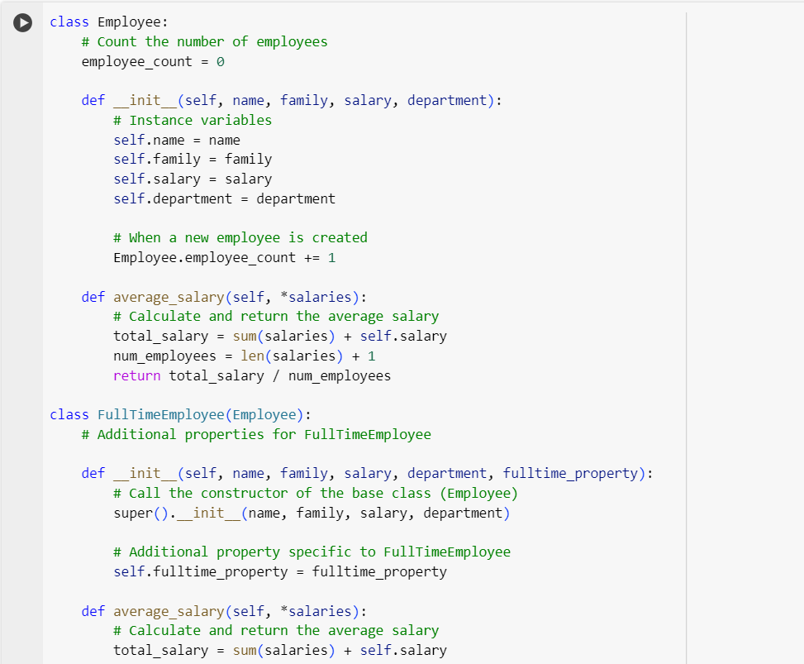

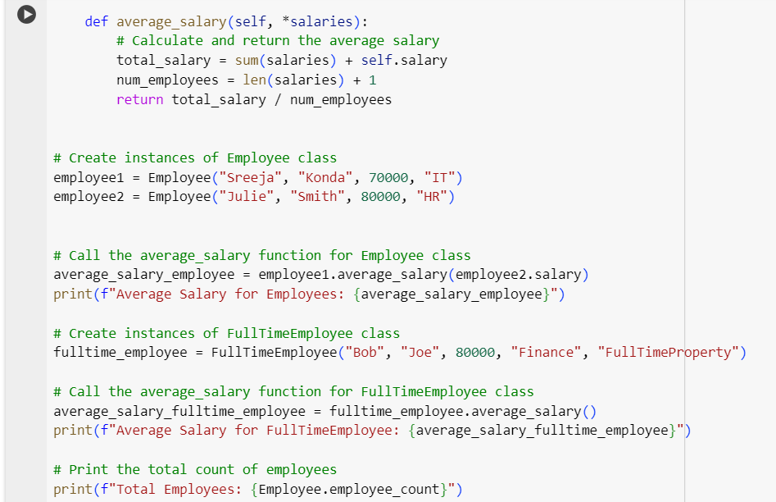

**Output**:



**Explanation**:

This snippet is to give the average salary of the employees. So the code includes initialization of employees data while creating instances of employee and full time employee and thyen giving the output of employee count and average salary.

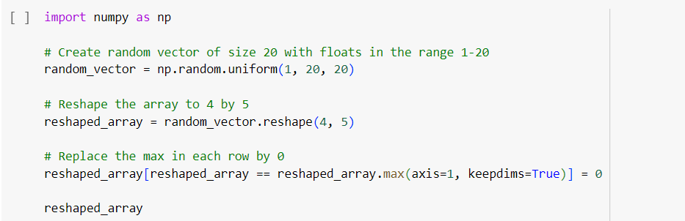

**Output**:

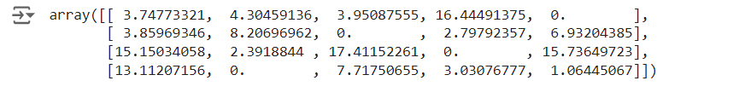

**Explanation**:

The above snippet is to give the output of an (4,5) array where the maximum values will give 0 as output.